1.Open your browser’s extension/add-ons manager

2. Review a l insta led extensions carefu ly,.Check permissions and reviews for each extension

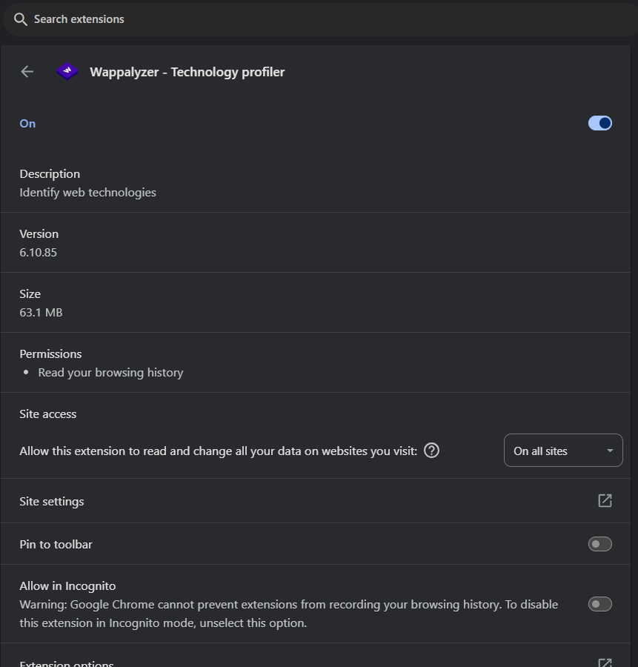

4.Identify any unused or suspicious extensions.

5.Remove suspicious or unnecessary extensions.

6.Restart browser and check for performance improvements.

**Chrome://restart**

7.Research how malicious extensions can harm users

Malicious browser extensions can significantly harm users by stealing sensitive data, monitoring browsing activity, injecting malicious code, and even hijacking user accounts. These extensions can be disguised as legitimate tools, making them difficult to detect and posing a serious threat to both individual users and organizations

1. Data Theft
2. Monitoring
3. Content Manipulation
4. Malware Distribution

**Detection and Prevention:**

* Be cautious about installing browser extensions, especially those from unknown developers.
* Review permissions requested by extensions before installing.
* Keep your browser and extensions updated.